THE BLUE HOLE QUEST:

Rood Holiday Adventure
Master Game Design Document (GDD) & Technical Specification V3
- Genre & Style: 8-Bit Action-Adventure / Side-Scrolling Platformer RPG (Zelda II: The Adventure of Link style)
- Target Frameworks: TypeScript / HTML5 Canvas (Vite), Godot 4, or GB Studio
- Target Platforms: Responsive Web App (Mobile Touch & Desktop Browser) & Retro ROM
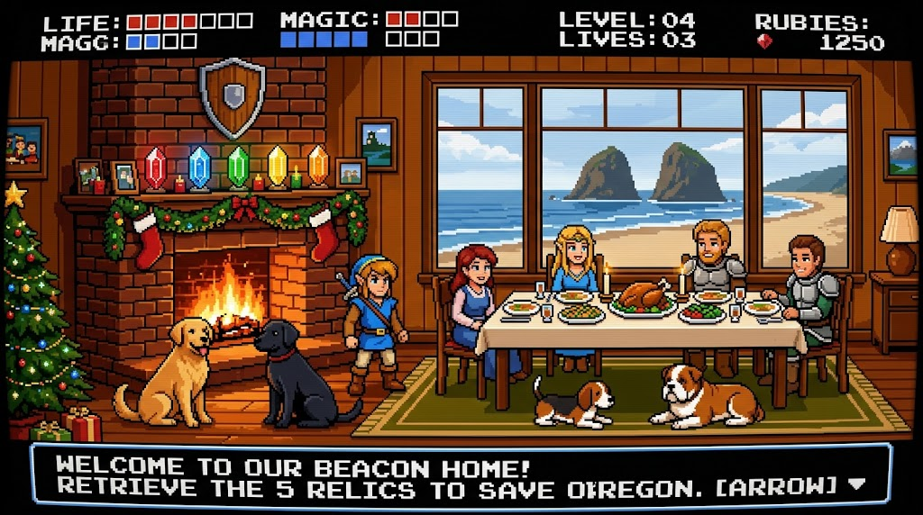

1. Executive Summary & Core Game Loop

1.1 Premise
A personalized 8-bit retro action-adventure game crafted as a family holiday gift. The player selects a household couple to venture out from the family sanctuary—The Blue Hole on 2nd Street in Rockaway Beach, Oregon. The holiday hearth cannot be ignited until the Five Sacred Relic Crystals are recovered from regional side-scrolling palaces across the Pacific Northwest, each guarded by other family members, their dogs, and boss avatars.

1.2 Dual Gameplay Loop
- Top-Down Overworld Map: Grid-based navigation representing real Pacific Northwest highway corridors (Hwy 26, Hwy 217, Hwy 99E, Columbia River Gorge/I-84, Santiam Pass/Hwy 20). Stepping onto wilderness tiles triggers random screen-wipe combats or Oregon Trail style comedy events.
- Side-Scrolling Towns & Sanctuaries: 2D platformer view for visiting homes, talking to family NPCs, resting at the Blue Hole fridge for full heals, and receiving cryptic clues.
- Side-Scrolling Action Palaces: Multi-room dungeons with elevator shafts, breakable blocks, locked doors requiring brass keys, technique Learning rooms, and multi-phase boss battles.
- Progression & Leveling: Upgrades to Attack, Magic, and Life along with newly Learned techniques (Upthrust, Downthrust) and spells (JUMP, REFLECT) gate regional highways and palace challenges.

2. Dynamic Family Duo Selection & Lead Mechanic
Instead of playing as Link, the player chooses one of the Five Family Teams at the start of the game. Whichever household is selected acts as the active on-screen player sprite (with custom weapons, animations, and passive traits), while the other four couples remain in their home palaces awaiting rescue / reunion.

2.1 The Playable Family Teams & Custom Weapons
Selected Family Team | Active On-Screen Duo & Visuals | Primary Weapon & Strike Animation | Starting Stats (ATK / MAG / LIF) | Passive Household Perk
Team Dad & Paula | Dad: Suspender overalls with Paula tagging alongside in her host apron. | Threaded Plumbing Wrench: Heavy blunt horizontal swing; smashes cracked blocks with base attacks. | ATK: 3  MAG: 1  LIF: 2 | Master Craftsman: +1 baseline blunt melee damage; immunity to tool recoil.
Team Jen & Omar | Omar: Tech headset, with Jen, Ari & Emmy and their little pup running in party formation. | Smart-Tech Stun Baton / Toy Wand: Fast-strike electric zap with wide vertical arc. | ATK: 1  MAG: 2  LIF: 3 | Parental Reflexes: +10% base movement speed; immunity to knockback from floor toys and Lego caltrops.
Team Jason & Hilary | Jason: Brewery tee with Hilary in high-fashion streetwear and sunglasses. | River Oak Mash Paddle: Long-reach horizontal sweep with wide forward cleave. | ATK: 2  MAG: 1  LIF: 3 | Riverbank Endurance: +2 starting max HP blocks; passive health regeneration (1 HP / 30s).
Team Joe & Cia | Joe: Tweed jacket & binder, with Cia and their two little watchdogs scouting ahead. | Enchanted Oak Pointer / Vineyard Pruner: Fast dual-poke thrust with high critical chance. | ATK: 1  MAG: 3  LIF: 2 | Academic Insight: -25% MP cost across all cast spells (SPELL_JUMP, SPELL_REFLECT).
Team Kris & Lea | Kris & Lea: High-desert climbing gear, trail packs, and their loyal Black Lab. | Carabiner Trekking Pole: Piercing forward thrust with extra reach. | ATK: 2  MAG: 2  LIF: 2 | Alpine Trekker: Completely immune to overworld snow and mud movement penalties.

2.2 Dynamic HUD & Narrative Replacement Rules
- HUD Nameplate: The top status bar dynamically displays the active team's name (e.g., DAD & PAULA, JEN & OMAR, JASON & Hilary, JOE & Cia, or Kris & Lea) along with their custom pixel portrait next to the LIFE and MAGIC meters.
- Dialogue String Interpolation: All NPC dialogue boxes dynamically swap references to address the active party by name:
  - Example: When talking to the Cabin Elder at Rockaway Beach:
  - "WELCOME, [ACTIVE_PARTY_NAME]! WITHOUT THE 5 FAMILY RELICS, THE HOLIDAY FIRE WILL NOT IGNITE. VENTURE INLAND!"

- Upthrust & Downthrust Adaptations:
  - Dad: Overhead pipe lift / Downward wrench anvil drop.
  - Omar / Jen: Overhead tech drone pulse / Downward pogo-toy bounce.
  - Jason / Hilary: Overhead paddle flip / Downward heavy keg stomp.
  - Joe / Cia: Overhead pointer spark / Downward shears dive.
  - Kris / Lea: Overhead ice-axe poke / Downward trekking-pole vault.
- The Bend Caldera Climax (Shadow Duel):
  - The final boss in Phase 2 is not "Shadow Link"—it is the Shadow Mirror of your Selected Team (e.g., Shadow Dad & Paula, Shadow Jason & Hilary), wielding identical weapons and dark mirrored movement!

3. World Hierarchy & Progression Matrix
[ 0. ROCKAWAY BEACH (The Blue Hole) ]
│
(Hwy 26 Fog Pass)
▼
[ 1. HILLSBORO WEST ] ──────► [ 2. HILLSBORO EAST ]
(Dad & Paula - Thumb) (Jen & Omar - Hound)
│
(Hwy 99E Connector)
▼
[ 4. WALLA WALLA, WA ] ◄───── [ 3. MILWAUKIE ]
(Joe & Cia - Leaf) (Jason & Hilary - Stein)
│
(Santiam Pass)
▼
[ 5. BEND (The Great Palace) ]
(Kris & Lea - Mountain statue )
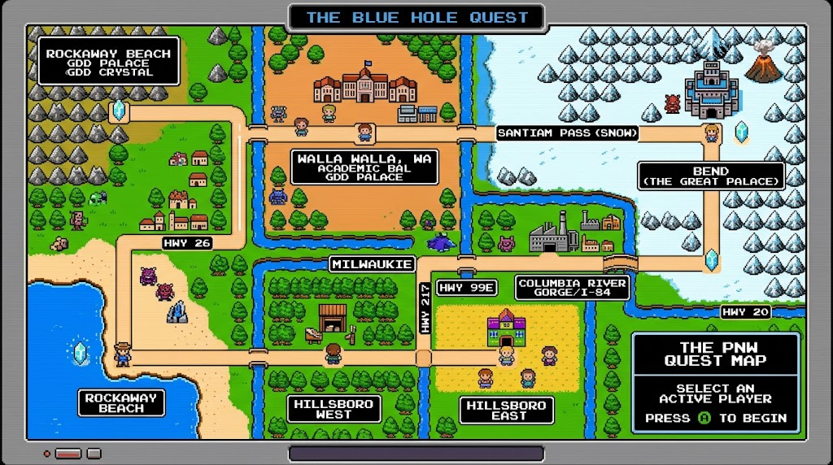

Zone / Hub | Realm / Palace | Household & Cast | Relic Crystal | Ability / Spell | Overworld Gate Cleared
0. Rockaway Beach | The Blue Hole (Home Base) | Whole Family Assembly | (All 5 Restored) | The Old Coleman Lantern | Hwy 26 Coast Range Pass
1. Hillsboro (West) | The Silicon & Sawdust Foundry | Dad & Paula | The Golden Thumb | Upthrust (Up + Attack) | Light Rail / Hwy 217 Corridor
2. Hillsboro (East) | The Chaos Playroom Citadel | Jen & Omar, Ari & Emmy (+ Dog) | The Crystal Hound | JUMP Spell | Hwy 99E South Corridor
3. Milwaukie | The Riverbank Brewhouse | Jason & Hilary | The Amber Beer Stein | Downthrust (Down + Attack) | Columbia River Gorge Route
4. Walla Walla, WA | The Academy Cellars | Joe & Cia (+ 2 Little Dogs) | The Emerald Leaf | REFLECT Spell | Santiam Pass Snow Wall
5. Bend | The Great Volcanic Caldera | Kris & Lea (+ Black Lab) | The Marble Mountain statue | Mastery of All Arts | Express Return to Rockaway

4. Detailed Zone & Palace Specifications

Zone 0: Rockaway Beach — The Blue Hole Sanctuary
- Location Profile: 2nd Street beach access in Rockaway Beach, Oregon overlooking Twin Rocks.
- System Role: Global spawn point, safe room, save checkpoint, and final altar mantelpiece.
- Hub Features:
  - The Fridge: Interacting with the fridge fully replenishes Life (HP) and Magic (MP).
  - The Fireplace Mantle: Houses 5 sockets for the Relics. Restoring a relic permanently spawns those family members in the living room as interactive NPCs.
- Key Item Acquired: KEY_ITEM_LANTERN (Pierces thick coastal fog on Highway 26).

Zone 1: Hillsboro (West) — The Silicon & Sawdust Foundry
- Cast: Dad & Paula.
- Theme: Downtown Old Town historic brick meets cleanroom automation and precision home workshop craftsmanship.
- Level Architecture:
  - Room 1 (Entry): Old Town brick facade dropping down an industrial lift into sublevels.
  - Room 2 (Assembly Line): Conveyor belts pushing the player toward spinning saw blades.
  - Room 3 (Circuit Core): Floating silicon sentry drones dropping diagonal laser sparks.
- Technique Unlocked: TECHNIQUE_UPTHRUST (Executed via JUMP + UP + ATTACK. Strikes ceiling switches, drops suspended lumber, and hits flying drones).
- Boss: The Silicon Architect — Shifts high and low wooden guards framed in copper heat sinks (Iron Knuckle style). In Phase 2, hurls spinning silicon wafer boomerangs that must be deflected before landing an Upthrust.
- Relic Awarded: RELIC_GOLDEN_THUMB.

Zone 2: Hillsboro (East) — The Chaos Playroom Citadel
- Cast: Jen & Omar, daughters Ari and Emmy, and their little adventure pup.
- Theme: High-energy smart home with tech command centers, bunk-bed platforms, and toy tripwires.
- Level Architecture:
  - Room 1 (Hardwood Gauntlet): Floor tiles covered in scattered plastic brick caltrops (spike damage).
  - Room 2 (Bunk Bed Maze): Multi-tier vertical climbing with ladders, sliding wagons, and dart drones.
  - Room 3 (Wi-Fi Server Ledge): High-altitude platforms reachable only by enhanced jumping.
- Spell Unlocked: SPELL_JUMP (Costs 2 MP blocks; doubles vertical leap to clear wide hazard pits).
- Boss: The Screen-Time Sentry & Toy Colossus — Mech-golem made of building blocks; Phase 2 features a detached hovering tablet monitor requiring SPELL_JUMP and TECHNIQUE_UPTHRUST.
- Relic Awarded: RELIC_CRYSTAL_HOUND.

Zone 3: Milwaukie — The Riverbank Brewhouse & Foundry
- Cast: Jason & Hilary.
- Theme: Clackamas and Willamette river confluences, active waterways, industrial brick foundries, and craft brewery cellars.
- Level Architecture:
  - Room 1 (Sluice Gate): Moving river currents pushing the player toward spiked pilings.
  - Room 2 (Fermentation Bay): Rolling oak keg obstacles descending ramps; timed steam vent geysers.
  - Room 3 (Brick Kiln Vault): Heavy iron grates and breakable brick floor plates hiding keys.
- Technique Unlocked: TECHNIQUE_DOWNTHRUST (Executed via JUMP + DOWN + ATTACK. Pogo-bounces across rolling kegs, smashes floor plates, and crushes armored helmets).
- Boss: The Master Brew-Golem — Heavy copper-kettle golem sweeping a massive mash paddle low and rolling mini-kegs. Vulnerable to a Downthrust on the head pressure valve.
- Relic Awarded: RELIC_AMBER_BEER_STEIN.

Zone 4: Walla Walla, WA — The Academy Cellars & Sunlit Vineyard
- Cast: Joe & Cia and their two little vineyard watchdogs.
- Theme: Sun-drenched rolling wheat hills, vineyard estate trellises, brick lecture halls, and subterranean barrel vaults.
- Level Architecture:
  - Room 1 (Lecture Hall): Flying notebooks, chalk dust hazards, and numbered switch puzzle doors.
  - Room 2 (Outdoor Trellis Climb): Vertical stone wall scaling on grapevines while dodging swinging fruit bunches.
  - Room 3 (Vault of Casks): Dark stone cellar with high-velocity rolling wine barrels and locked iron gates.
- Spell Unlocked: SPELL_REFLECT (Costs 3 MP blocks; erects an elemental chill barrier that parries spells, flying corks, and chalk back at casters).
- Boss: The Dean of the Vine — Tweed-robed scholar hovering above ground firing chalk runes and high-speed corks. Cast SPELL_REFLECT to stun the boss, followed by a Downthrust.
- Relic Awarded: RELIC_EMERALD_Leaf.

Zone 5: Bend — The Great Volcanic Caldera (The Climax)
- Cast: Kris & Lea and their Black Lab.
- Theme: Ponderosa pines, high-desert basalt crags, mountaineering ascents, camp gear, and subterranean lava tubes.
- Level Architecture:
  - Room 1 (Basalt Bouldering Crag): Sheer cliff face with carabiner ropes, climbing anchors, and falling rock scree.
  - Room 2 (Lava Tube Labyrinth): Disappearing basalt blocks suspended over instant-death magma pits; camp stove burner steam traps.
  - Room 3 (Caldera Trial): Combined puzzle requiring Upthrust on ceiling stalactites, Downthrust on basalt golems, and Reflect against fire skulls.
- Boss Encounters:
  - Phase 1: The Cascade Titan (The Mountain King) — Basalt elemental wielding a trekking pole spear. Slams ground to trigger boulder falls and charges with high/low stances.
  - Phase 2: Shadow Link (The Mountain Doppelgänger) — A shadowy mirrored silhouette wielding a cracked baseball bat. Frame-perfect mimicry of all player attacks.
- Relic Awarded: RELIC_MARBLE_Mountain statue .

5. The Oregon Trail Parody Calamities & Minigames
When traveling across overworld highway routes (Hwy 26, Hwy 99E, Santiam Pass), green-screen text prompt cards trigger at random:

5.1 Calamity Cards
- The Coast Range (Hwy 26):
"YOU HAVE REACHED THE WILSON RIVER CROSSING.\n1. ATTEMPT TO FORD THE TRAFFIC.\n2. CAULK THE SUBARU AND FLOAT.\n3. WAIT FOR ODOT TOW TRUCK."
- Suburban Gridlock (Hwy 217):
"OMAR'S TECH GEAR OVERHEATED IN TRAFFIC. LOSE 2 MP."
- Costco Bulk Run (Milwaukie / Clackamas):
"YOUR PARTY FOUND 450 LBS OF HOLIDAY SNACKS, BUT COULD ONLY CARRY 40 LBS."
- Santiam Pass Blizzard:
"A BLIZZARD STRIKES! Kris & Lea's BLACK LAB DUG A SNOW SHELTER. FULL PARTY HEALED!"

6. Leveling, Save System & Cross-Platform UI

6.1 Three-Stat Zelda II Leveling System
Defeating overworld minions and palace guardians grants Experience Points (EXP). Leveling thresholds allow upgrading one of three stats up to Level 8:
- ATTACK Level: Increases base damage of sword/pipe slashes, Upthrust, and Downthrust.
- MAGIC Level: Decreases MP consumption of SPELL_JUMP and SPELL_REFLECT.
- LIFE Level: Reduces incoming damage from enemy attacks, hazards, and spikes.

6.2 Local Storage & Password Save System
- Auto-Save: Saves game state to browser localStorage on entering towns or checking the Blue Hole fridge.

6.3 Responsive Viewport & Touch Controls
- Display: Fixed $256 \times 240$ internal canvas scaled via CSS pixelated aspect ratio centering.
- Touch Overlay: Dynamic virtual D-pad on the left thumb; A (Jump), B (Attack), SELECT (Spell), START (Pause) on the right thumb for mobile play.
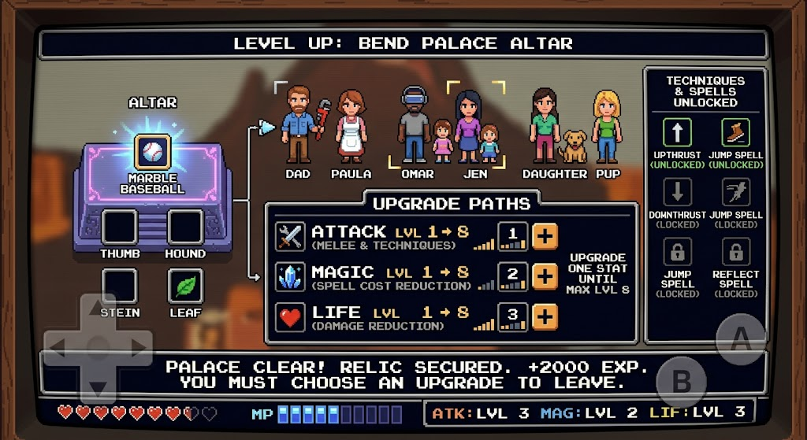

7. Sprite & Animation Specifications
Animation State | Frames | Hitbox (W×H) | Frame Timing | Mechanic / Notes
Idle | 2 | $12 \times 28$ px | 500ms / frame | Subtle breathing bounce
Walk | 4 | $12 \times 28$ px | 120ms / frame | 4-step stride cycle
High Slash | 3 | $24 \times 28$ px | 60ms / frame | Forward strike at shoulder level
Crouch & Low Slash | 2 | $12 \times 18$ px / $24 \times 18$ px | 60ms / frame | Low hitbox ducking under high projectiles
Jump / Airborne | 1 | $12 \times 24$ px | — | Tucked leg jumping pose
Upthrust (Mid-air) | 2 | $12 \times 32$ px | 80ms / frame | Blade/pipe vertical strike overhead
Downthrust (Mid-air) | 2 | $12 \times 32$ px | 80ms / frame | Downward strike; pogo-bounces on contact
Shield Block | 1 | $14 \times 28$ px / $14 \times 18$ px | Passive | Automatically absorbs horizontal enemy sparks

8. Complete Dialogue Script (JSON)
JSON
{
"ROCKAWAY_HUB": {
"welcome_sign": "2ND STREET ACCESS ──► THE BLUE HOLE.\nREST THY WEARY BONES.",
"fisherman": "EAST WINDS ARE BLOWING COLD.\nHIGHWAY 26 IS SHROUDED IN DENSE COASTAL FOG.",
"cabin_elder": "WITHOUT THE 5 FAMILY RELICS, THE HOLIDAY FIRE\nCANNOT BE IGNITED. BRING THEM HOME!",
"fridge_heal": "CHECKED THE BLUE HOLE FRIDGE...\nFULL LIFE AND MAGIC RESTORED!",
"mantle_inspect_incomplete": "THE HEARTH SITS COLD AND DARK.\nPLACE ALL 5 RELICS TO COMMENCE THE FEAST.",
"mantle_complete": "THE FLAME ROARS TO LIFE!\nTHE WHOLE CREW ASSEMBLES ON 2ND STREET!"
},
"HILLSBORO_WEST": {
"dad_greeting": "MEASURE TWICE, CUT ONCE.\nTHE OVERHEAD BREAKERS ARE TRIPPED!\nSEEK THE UPWARD STRIKE WITH THE PIPE.",
"paula_greeting": "TAKE THIS ICED REFRESHMENT.\nTHY SPIRIT AND RESOLVE GROW STRONGER.",
"relic_unlocked": "RETRIEVED THE GOLDEN THUMB!\nCRAFTED FROM HICKORY. SYMBOL OF CRAFTSMANSHIP."
},
"HILLSBORO_EAST": {
"jen_greeting": "WATCH THY STEP ON THE HARDWOOD!\nARI AND EMMY SCATTERED PLASTIC BRICKS ACROSS THE FLOOR.",
"omar_greeting": "THE WI-FI ROUTER IS ROUTING MAXIMUM POWER.\nCAST THE JUMP SPELL TO SCALE HIGH SHELVES!",
"ari_and_emmy": "WE ARE ON A SECRET ADVENTURE!\nOUR DOG HOLDS THE SPECIAL BARK POWER!",
"dog_interact": "*WOOF! WOOF!*\n(THE PUP WAGS ITS TAIL AND DROPS A RED MAGIC JAR).",
"relic_unlocked": "RETRIEVED THE CRYSTAL HOUND!\nPROTECTOR AGAINST FLOOR CLUTTER AND LIVING ROOM CHAOS."
},
"MILWAUKIE": {
"jason_greeting": "THE CLACKAMAS RUNS FAST AND COLD.\nUSE THE DOWNTHRUST TO CRACK THE RIVER LOCKS!",
"Hilary_greeting": "REST IN THE SUNNY TAPROOM YARD.\nOUR CRAFT BREW REPLENISHES THY VITAL METERS.",
"relic_unlocked": "RETRIEVED THE AMBER BEER STEIN!\nRADIATING CRAFT HOSPITALITY AND RIVERBANK SPIRIT."
},
"WALLA_WALLA": {
"joe_greeting": "ACADEMIC DISCIPLINE MEETS HARVEST CHILL.\nUSE THE REFLECT SPELL TO REPEL HIGH-SPEED CHALK!",
"Cia_greeting": "OUR TWO PUPS KNOW EVERY SECRET VINEYARD PATHWAY.\nREST AND ENJOY THE SUNSHINE!",
"two_dogs_interact": "*YIP! BARK!*\n(THE TWO LITTLE PUPS DIG UP A HIDDEN POTION).",
"relic_unlocked": "RETRIEVED THE EMERALD LeaF!\nMAXIMUM INLAND TRANQUILITY AND HARVEST WISDOM."
},
"BEND": {
"Kris_greeting": "THE ASCENT UP THE CALDERA IS STEEP.\nTIME THY JUMPS ON THE BASALT LEDGES!",
"Lea_greeting": "OUR LAB SCOUTED THE HIGH RIDGE TRAIL.\nTAKE THIS TRAIL MIX FOR PEAK ENDURANCE!",
"black_lab_interact": "*WOOF!*\n(THE BLACK LAB RETRIEVES A GOLDEN FAIRY!).",
"relic_unlocked": "RETRIEVED THE MARBLE Mountain statue !\nBALANCED WITH DIAMOND PRECISION AND SUMMIT GRIT."
}
}

9. Grand Finale Sequence
- The Bend Altar Cleared: Recovering RELIC_MARBLE_Mountain statue in Bend opens an express transit path back to Rockaway Beach.
- The Mantle Altar Cutscene: Link enters The Blue Hole living room on 2nd Street. All 5 relics slot into their sockets:
  - [1] The Golden Thumb (Dad & Paula)
  - [2] The Crystal Hound (Jen, Omar, Ari, Emmy & Pup)
  - [3] The Amber Beer Stein (Jason & Hilary)
  - [4] The Emerald Leaf (Joe, Cia & 2 Little Dogs)
  - [5] The Marble Mountain statue (Kris, Lea & Black Lab)
- Fireplace Ignition: A roaring 8-bit bonfire ignites in the hearth. Sprites for all family members and all four dogs gather around the banquet table.
- End-Screen Text Crawl:
Plaintext
============================================================
THE BLUE HOLE HEARTH IS RESTORED!
THE WHOLE FAMILY HAS GATHERED ON 2ND STREET.
THE HOLIDAY FEAST IS SERVED!
MERRY KrisTMAS TO THE ENTIRE CREW!
============================================================

10. Hidden Easter Egg System: Budda the Drunk Ginger Cat
Throughout the Pacific Northwest overworld, towns, and palaces, players can find secret, destructible walls, hidden tree hollows, and roof access points hiding Budda, the family’s chunky, mischievous, fermented-beverage-loving orange tabby.
Interacting with Budda triggers hilarious Zelda II style cryptic non sequiturs, hiccups, and random gameplay buffs or mild party debuffs.
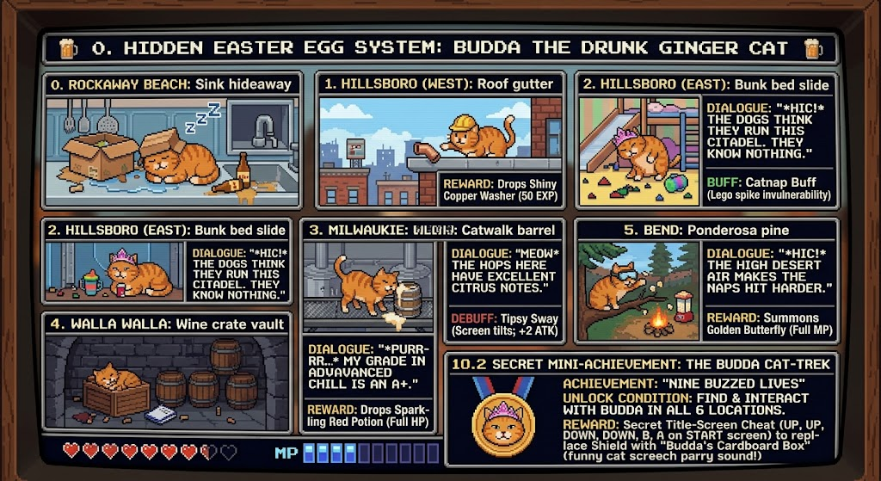

10.1 Budda Sighting Locations & Antics
Region / Zone | Hidden Location | Budda's Antics & Visual Animation | Interaction Prompt & Dialogue | Reward / Calamity
0. Rockaway Beach | Asleep in the 2nd Street sink behind the fridge. | Squeezed into an empty cardboard box with a knocked-over cider bottle; snoring with Zzz bubbles. | "*HIC!* I AM NOT ERROR. I AM BUDDA. DO NOT TURN ON THE FAUCET." | Tosses player a Fish Bone (+1 Magic Block).
1. Hillsboro (West) | Downtown Old Town roof gutter above the garage. | Batting a loose copper plumbing pipe elbow off the ledge; wearing a miniature hardhat at a crooked angle. | "*BURP!* GRAVITY IS MERELY A SUGGESTION ON 2ND STREET." | Drops a Shiny Copper Washer (Worth 50 EXP).
2. Hillsboro (East) | Hidden under Ari & Emmy's bunk bed slide. | Wearing a pink princess tiara sideways, aggressively grooming his belly while knocking over a sippy cup. | "*HIC!* THE DOGS THINK THEY RUN THIS CITADEL. THEY KNOW NOTHING." | Grants Catnap Buff (Temporary invulnerability to Lego spike damage).
3. Milwaukie | Balanced on the high fermentation vat catwalk. | Lapping up spilled craft IPA foam from the rim of a keg; visibly wobbling on three paws. | "*MEOW-HIC!* THE HOPS HERE HAVE EXCELLENT CITRUS NOTES." | Party is inflicted with Tipsy Sway (Screen tilts slightly for 20 seconds; +2 Attack power).
4. Walla Walla, WA | Curled up in an empty oak wine crate behind the lecture hall. | Chewing on a stray lesson plan binder and batting wine corks across the cobblestones. | "*PURRRR...* MY GRADE IN ADVANCED CHILL IS AN A+." | Drops a Sparkling Red Potion (Full HP restore).
5. Bend | Perched in a Ponderosa pine above the camp stove. | Wearing tiny climbing goggles; swatting at falling camp popcorn over the campfire. | "*HIC!* THE HIGH DESERT AIR MAKES THE NAPS HIT HARDER." | Summons a Golden Butterfly (Fully restores MP).

10.2 Secret Mini-Achievement: The Budda Cat-Trek
- Achievement: "Nine Buzzed Lives"
- Unlock Condition: Find and interact with Budda in all 6 locations (Rockaway, Hillsboro W, Hillsboro E, Milwaukie, Walla Walla, Bend).
- Reward: Unlocks the secret title-screen cheat code (UP, UP, DOWN, DOWN, B, A on the start screen) to replace the player's shield with "Budda's Cardboard Box", which plays a funny cat screech sound whenever Link parries a high-speed projectile!
Here is the update for Section 10, making Budda the Drunk Ginger Cat provide a full health regeneration effect whenever you interact with him:

10.3 Budda's Blessing: Full Health & Vitality Regeneration
Whenever a player discovers and interacts with Budda in any secret nook, the encounter immediately grants "Budda's Catnap Refresh":
- Instant Full Restoration: Restores the active family team's LIFE (HP) and MAGIC (MP) meters to 100% maximum capacity, complete with a warm screen-flash and a classic 8-bit purring chime.
- Lingering Regen Aura: Grants the party a 30-second passive Health Regeneration Buff, slowly ticking +1 HP every 3 seconds to shrug off lingering poison, spikes, or hazard hits.
- Visual & Audio Feedback: A floating bowl of warm milk and catnip icon appears above the party's heads, followed by Budda rolling onto his back, batting the air, and letting out a relaxed *PURRR-HIC!*.

